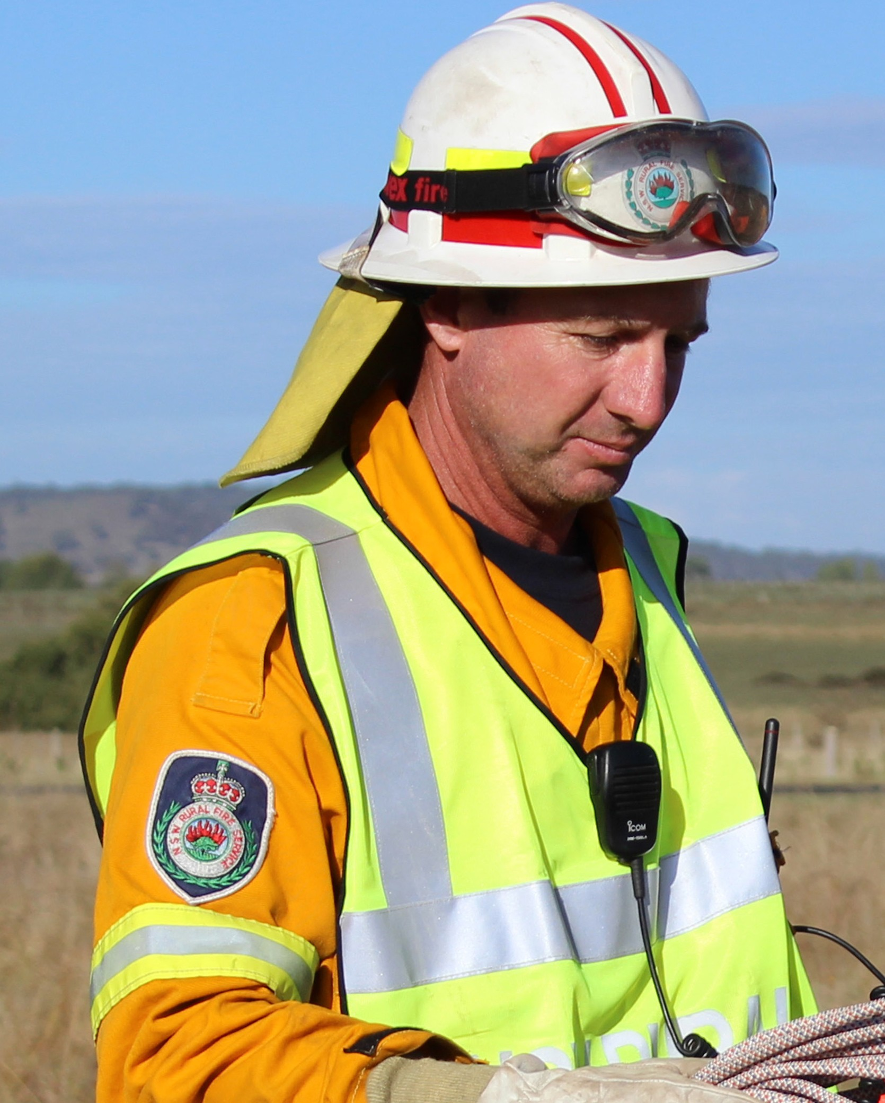

DEVELOPMENT PLANNING
A guide to developing a
Bush Fire Emergency Management and Evacuation Plan

© State of New South Wales through the NSW RURAL FIRE SERVICE 2014
The NSW RURAL FIRE SERVICE (NSW RFS)
encourages the availability, dissemination and exchange of public information. You may copy, distribute, display, download and otherwise freely deal with this material for personal, in-house or non- commercial use, on the condition that you include the copyright notice © State of New South Wales through the NSW RURAL FIRE SERVICE 2014 on all such uses. In the event that you wish to copy, distribute, display, download, store, or use this material for a purpose other than personal, in-house or non-commercial use, you must obtain permission from the NSW RFS by writing to the following address:

Commissioner
NSW RURAL FIRE SERVICE
Locked Mall Bag 17 Granville NSW 2142
You must also obtain permission from the NSW RFS if you wish to:
charge others for access to the work (other than at cost);
include all or part of the work in advertising or a product for sale;
modify the material; or
use any trade mark from this publication, including the NSW RURAL FIRE SERVICE Crest.

DISCLAIMER STATEMENT
While the material within this publication is current at the time of writing changes in circumstances after the time of publication may impact on the accuracy of the material. Individuals are responsible for ensuring they have the most current version of this publication
The information and material contained herein is general in nature and is intended for your use and information. The NSW RURAL FIRE SERVICE (NSW RFS) disclaims, to the extent permitted by
law, all warranties, representations or endorsements, express or implied, with regard to the material contained herein. The NSW RFS does not warrant
or represent that the material contained herein is free from errors or omissions, or that it is exhaustive. Users should exercise their own skill and care with respect to its uses. You must not assume that this material will be suitable for the particular purpose that you had in mind when using it.
The NSW RFS disclaims any liability (including but not limited to liability by reason of negligence) to the users of the material for any loss, damage, cost or expense whether direct, indirect, consequential or special, incurred by, or arising by reason of,
any person using or relying on the material and whether caused by reason of, any error, omission or misrepresentation in the material or otherwise.
Users of the Website will be responsible for making their own assessment of the material and should verify all relevant representations, statements and information with their own professional advisers.
Prepared by NSW Rural Fire Service –December 2014

Table of Contents

Preface 4
What is an at risk development? 5
Why develop a Plan? 5
What if I already have an Emergency Plan? 6
STEPS TO PRODUCE A PLAN 7
STEP 1: Establish an Emergency Planning Committee 8
STEP 2: Analyse site characteristics 9
STEP 3: Decide Primary Action 13
Analyse the bush fire situation 13
STEP 4: Analyse requirements for Sheltering and Evacuation 14
Identify a refuge (sheltering) 15
Identify a refuge (evacuation) 16
Determining transportation to refuge (evacuation) 17
STEP 5: Develop emergency procedures 18
Bush Fire Action Statements 18
Factors to be considered for Action Statements 19
Occupant/employee listing 20
Contact details of family members 20
Site layout 21
STEP 6: Training of staff/occupants 22
Additional Awareness Training 22
TEMPLATE
Bush Fire Emergency Management and Evacuation Plan APPENDIX 1: Example Bush Fire Action Statements and Triggers APPENDIX 2: Example of a Site Layout

NSW RURAL FIRE SERVICE – GUIDE TO DEVELOPING A BUSH FIRE EMERGENCY MANAGEMENT PLAN 3

Preface
This guide is aimed at assisting representatives for at risk developments to prepare a Bush Fire Emergency Management and Evacuation Plan (Plan).
For new developments in bush fire prone areas, conditions of consent may also require the preparation of a Plan.
The guide will assist in filling out the Bush Fire Emergency Management and Evacuation Plan Template provided in this document.
The guide outlines a step-by-step process to address factors that are to be considered when developing
a Plan. There are six steps in the process. As each step is completed, details should be recorded in the template.
Where a Plan is required to meet a development consent condition, a copy is likely to be required by the certifying authority.
You should also consider providing a copy to the local Fire Service to assist in their pre-incident planning.
Individuals wanting to consider their bush fire emergency management should refer to the Bush Fire Survival Plan available at www.rfs.nsw.gov.au.
If you would like more information on emergency management planning for bush fires, please contact:
NSW Rural Fire Service Locked Mail Bag 17 GRANVILLE NSW 2142
1800 NSW RFS
(1800 679 737)
www.rfs.nsw.gov.au

What is an at risk development?
At risk developments are facilities that regularly have a large number of occupants that may rely on others for their wellbeing or be unfamiliar with the local area. As such a greater degree of planning and coordination is required to ensure occupants safety. In the event of a bush fire, a Bush Fire Emergency Management and Evacuation Plan (Plan) will outline what actions are to occur and arrangements for relocation.
The Environmental Planning & Assessment Act (1979) and the Rural Fires Act (1997) provides for developments on Bush Fire Prone Land to
incorporate bush fire protection measures to reduce the impacts of a bush fire. This legislation, along with the NSW RFS publication, Planning for Bush Fire Protection, refers to Special Fire Protection Purposes (SFPP).
An at risk development includes, but is not limited to, those facilities that are often referred to as SFPP
development. Typically, a SFPP development includes the following:
a school
a child care centre a hospital
a hotel, motel or other tourist accommodation
a building wholly or principally used as a home or other establishment for mentally incapacitated persons
seniors housing within the meaning of State Environmental Planning Policy (Housing for Seniors or People with a Disability) 2004
a group home within the meaning of State Environmental Planning Policy No 9—Group Homes
a retirement village.
Other development types that may need to consider a Bush Fire Emergency Management and Evacuation Plan include commercial/industrial, multiple occupancy (land sharing) and community
title estates.

Why develop a Plan?
Bush fires are a part of the Australian environment, with NSW being one of the more bush fire prone areas in the world. As the population increases, development encroaches further into bush land areas, increasing the number of persons and property potentially affected by bush fires.
Bush fire attack essentially takes five forms:
Wind: Strong winds resulting from severe bush fires will drive embers into vulnerable areas of a building, preheat and dry fuel ahead of a fire, lift roofing and extend flames along a more horizontal plane closer to building elements.
Smoke: While smoke will cause minimal damage to property, it can severely affect the health of residents. Smoke is a significant factor in at risk developments, particularly where residents are susceptible to respiratory disorders. Smoke can also reduce visability during evacuation or shelter situations.
Embers: Ember attack is responsible for most bush fire related building fires. Embers can also cause spotting in advance of the bush fire and ignite building elements.
Radiant heat: Radiant heat can severely impair the health of residents and the integrity of building elements. Radiant heat can prevent emergency services personnel assisting occupants of at risk developments.
Flame: Flame attack will severely restrict fire fighting operations, resulting in the ignition of building elements and a threat to the health of residents and their capacity to evacuate the area.
The preparation of a Plan aims to improve the preparedness of at risk developments from bush fire attack. The plan should identify the steps to be followed in the event of a bush fire.

NSW RURAL FIRE SERVICE – GUIDE TO DEVELOPING A BUSH FIRE EMERGENCY MANAGEMENT PLAN
5

What if I already have an Emergency Plan?
Many facilities have procedures to facilitate the safe movement and assist in the evacuation of occupants. These procedures are normally referred to as an Emergency Plan as outlined in Australian Standard AS3745 Planning for emergencies in facilities 2010 and AS4083 Planning for emergencies – Health care facilities 2010.
An Emergency Plan provided by these standards, has occupants evacuate buildings to an assembly
point in the event of an emergency. However for bush fires, these procedures may not adequately address the safety of occupants and other related issues that may result from a bush fire emergency. For example occupants may be relocated out into the open, exposing them to the heat and smoke from a bush fire.
A Bush Fire Emergency Management and Evacuation Plan will identify appropriate procedures for occupants to follow in the event of a bush fire and is to contain the following minimum requirements:
Name and address of facility
Contact details (including phone number)

Number of employees/occupants Number of occupants with support needs Primary Action: (evacuate or shelter)
Details of location or address of Primary Action
Details of location or address of back-up/ pre-emptive procedures
Procedures for Primary Action and back-up actions
Assembly point(s) and transportation arrangements (evacuation only)
Action Statements (before, during and after a bush fire)
Site layout of facility
Attachments will be dependent upon the type of facility and other associated factors. These attachments may include;
Occupant/employee listing
Contact details for parents/guardians
The NSW RFS recommends the use of the template provided in Appendix 1 as it provides the basis of a Plan and addresses the above requirements.

STEPS
to produce a plan

STEP 1
STEP 2
STEP 3
STEP 4
STEP 5
STEP 6

Establish an Emergency Planning Committee (EPC) Analyse site characteristics
Decide Primary Action (evacuation or sheltering) Analyse the requirements for evacuation and sheltering
Develop emergency procedures -Bush Fire Action statements Training staff and occupants

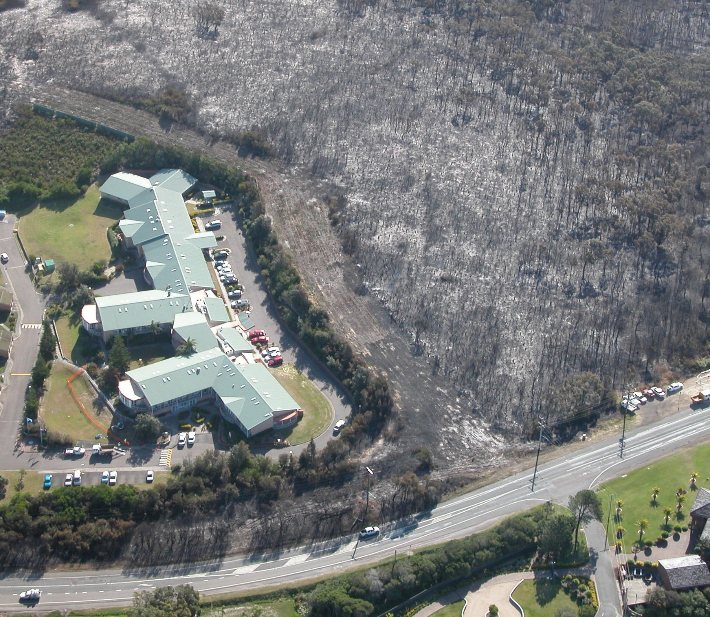

NSW RURAL FIRE SERVICE – GUIDE TO DEVELOPING A BUSH FIRE EMERGENCY MANAGEMENT PLAN 7

STEP 1

Establish an Emergency Planning Committee

The first step is to establish an Emergency Planning Committee (EPC) if one has not yet been established for your facility.
The EPC is a consultative group comprised of a representation of those who may work, live or are occupants at the facility. The group normally
consists of senior management, tenants, staff and chief and deputy chief wardens.
The role of the EPC is to actively participate in the planning process and identify the roles and likely participants who will be responsible for the implementation of the Plan and its procedures during an emergency.
The role of the EPC is to:
establish and implement emergency plans and procedures
identify duties and responsibilities of positions formulate emergency procedures
ensure employees and other occupants are educated and trained on emergency procedures
ensure all occupants are aware of the emergency procedures for the development
Regularly review the plan to ensure it remains practical and current
Roles and responsibilities associated with a Plan will need to be assigned to staff including:
coordinating and arranging transport
physically relocating occupants from one place to another
ensuring all buildings are properly prepared to limit the impact of a bush fire
initiating any bush fire protection measures such as sprinkler systems
liaising with emergency services.
If there is an existing EPC, it is likely that there is an existing Emergency Plan, with roles and responsibilities. The Emergency Plan should be cross referenced for bush fire emergencies.
For information on chief warden and warden positions, refer to Australian Standards AS3745 Planning for emergencies in facilities 2010 and AS4083 Planning for emergencies – Health care facilities 2010.

STEP 2

Analyse site characteristics

To prepare an appropriate Plan you should consider the characteristics of a site such as:
the type of facility
where is the facility located
how it may be affected by a bush fire how many occupants there are and if any
occupants have ‘support needs’ that need to be considered.
Preparing a Plan requires an understanding of how a bush fire may affect a site and the consequences on its occupants. For a better understanding of the bush fire situation of a particular area, consider
consulting with the NSW RFS and other emergency services.
As part of the consultation, you should keep the contact details of those people within the different agencies up to date. This will improve
communications and will make you aware of any situations that may affect your pre-planning.
To assist in working through potential issues for a site, a range of questions to help in understanding the bush fire situation and how it may affect the facility and the occupants are available on the following pages.
Bush fire prone area is land that can support a bush fire or is likely to be affected by bush fire attack. It is not determined by the frequency in which bush fires may have occurred in the past. Facilities that are within proximity of bush fire prone land should prepare a Bush Fire Emergency Management and Evacuation Plan.
Contact details for emergency service agencies are to be included in the Bush Fire Emergency Management and Evacuation Plan

Is the facility in a bush fire area?

Yes No
✔
Contact your local council to determine if you are bush fire prone.

What type of facility is the Plan for?

School Hospital
✔
Child care centre Commercial buildings Seniors Living Industrial buildings Group Home (SEPP 9) Tourist (hotel or motel) Mental health facility
Other tourist accommodation (eg. caravan park or camping)
Retirement Village Other

The logistical arrangements for the numbers of occupants within the facility may be complicated and you may need to consider alternate accommodation, transport, health care, food supplies and staffing ratios.

How many occupants within the facility?

84 pupils and 10 staff

How many occupants reside within the facility?

.N...i.l.......................................................................................

How many staff work within the facility?

.10...................................................................................

What is the staff/occupant ratio?
.1....in 9...................................................................................
How many potential temporary occupants (tourists, school students, visitors etc.)
.4..-..2..0.....................................................................................

Are any of the following occupants types at the facility and if so how many?

_0_ __ Children (under five years of age)
_____ Tourists (caravan/camping)
_85 __ Children (primary school)
_____ Tourists (motel/resort)
_____ Children (high school)
_10_ ___ Day time only employees
_____ Dependent aged
_____ Independent aged
_____ Mentally/physically disabled
_<_2_0__ Other _P_a_re_n_t_s __________________

The type and number of occupants may influence where these occupants should take refuge during a bush fire emergency.
The type of occupants may influence Action Statements.
With tourists, for example, you may need to consider whether they know the local area and have bush fire awareness.
Older persons may have restricted mobility and require assistance if relocated.
Children require supervision and their age will determine the level of supervision.

Are there occupants who suffer from asthma or other medical conditions where smoke or anxiety may exacerbate their illness or condition?

Yes No
✔
If yes, it may be more appropriate to move these people from the facility to a location away from the effects of a bush fire well in advance.

Asset Protection Zones (APZ) provide space for fire fighters and other emergency service personnel to support or evacuate occupants and reduce the impacts of radiant heat, smoke and embers on them whilst this is occurring.

Is there an APZ in place that will limit a bush fire spreading to a building or a bush fire starting around a building?

Yes No
✔
You should consult with the NSW RFS to determine if APZs are suitable.
Refer to Standards for Asset Protection Zones for maintenance requirements of an APZ
If yes, the facility may be suitable for occupants to remain on-site and indoors away from the effects of a bush fire as a Primary Action
(on-site refuge).
If no, consider a plan with Primary Action to evacuate occupants early to another location away from the effects of a bush fire
(off-site refuge).

Safe access arrangements for residents to evacuate an area whilst emergency service personnel are accessing the same area to suppress a bush fire are essential. Alternative access/way out routes will also assist if part of the road system is cut by bush fire.

How accessible is the property within the local area?

✔

Multiple roads in and out of the property One road in and out
Multiple roads provide alternative routes to transport occupants to an off-site refuge.
A single road accessing the site may cause traffic problems. Early departure, well before fire fighting units arrive, is recommended.

Does the transport route go through or near potential bush fire areas?

Yes No
✔

It is not appropriate to move occupants through an area where a bush fire may be burning or is predicted to burn through.
Alternate travel routes may need to be considered.

What is the condition of the buildings on site?
✔

Well maintained Reasonably maintained Poorly maintained
Older buildings or poorly maintained buildings are more vulnerable to bush fire attack, especially embers.
Gardens adjacent to buildings are a source of fuel for a fire.

Are the buildings constructed against bush fire attack?

Yes No Unknown
✔
Australian Standard AS3959 Construction of buildings in bush fire prone areas outlines building standards.
Windows and doors are vulnerable to bush fire attack and provide possible entry points into the building for embers.
Appropriately prepared and constructed buildings can offer protection during a bush fire reducing the likelihood of bush fire related injury and fatality.

STEP 3

Decide Primary Action (sheltering or evacuation)

The decision to evacuate or shelter under general bush fire conditions is one of the more important decisions to be made. This decision needs to be based upon a good understanding of the location, occupants and the effects of bush fire.

What is the difference between sheltering and evacuation?

Sheltering is the process of moving people to a location that is within close vicinity of where they occupy, but away from the effects of a bush fire (eg. moving school children to a gymnasium, or moving occupants to a common room).
Sheltering requires an on-site refuge which is a building within the property that is able to adequately accommodate the occupants that has adequate protection from the effects of bush fire.
Evacuation is the process of moving people from where they are staying to another location some distance away from the effects of a bush fire, to a safer location.
Evacuating requires an off-site refuge which is a building or location some distance away from the property and from the effects of bush fire that
is able to accommodate all the occupants being evacuated.

Analyse the bush fire situation

Analysing the bush fire situation should provide an understanding of how a bush fire may affect the
site and its occupants. The following questions have been provided to assist in deciding whether the Primary Action should be to evacuate or to shelter.

Is the facility likely to be affected by radiant heat and or direct flames?

Yes No
✔
If yes, safe evacuation is more appropriate

Are there occupants that could be susceptible to smoke who should be moved to another location due to medical conditions?

Yes No
✔
If yes, safe evacuation is more appropriate

Are there buildings with adequate Asset Protection Zones and building standards located away from a direct bush fire threat?

Yes No
✔
If yes, sheltering may be appropriate

STEP 4

Analyse requirements for sheltering and evacuation

Procedures for both sheltering and evacuation are to be developed, with one identified as the Primary Action to be followed during a bush fire. This is to ensure that if for any reason the Primary Action
is not achievable, the facility is not left without procedures to follow.
Facilities with sheltering as their Primary Action will have evacuation procedures in case they can no longer shelter or emergency services call for a pre-emptive evacuation due to catastrophic or extreme bush fire conditions.
Facilities with evacuation as their Primary Action will have sheltering procedures to implement in case a bush fire occurs and there is insufficient time to evacuate.
While it may be appropriate to plan to shelter if there is a bush fire emergency, this may not
always be feasible particularly during extreme or catastrophic conditions. Emergency services may decide to evacuate areas for public safety. For this reason procedures to evacuate to a refuge are required to ensure the necessary planning and coordination arrangements are in place.
Work through both the evacuation and sheltering steps when developing your Plan – no matter which is identified as your Primary Action.
An important factor when planning for emergency procedures is that under intense conditions it is common for people to behave irrationally and this may increase the time taken to move people.

Identify an on-site refuge
A refuge is required when sheltering and should be a building within the site that is able to accommodate all occupants away from the effects of the bush fire.
Sheltering is generally used where the facility includes buildings that are away from a direct threat of a bush fire during general bush fire conditions.
Remember that emergency services may call for a pre-emptive evacuation of the facility for public safety.
Sheltering procedures are also important as a back up option. Bush fires can start within close proximity to the property, leaving insufficient time for evacuation. In these circumstances occupants are more likely to be safer remaining in an on-site refuge on site rather than trying to evacuate.

When identifying a refuge, consider the following:

Is the property well maintained and kept free from a build up of fuel and leaf litter in gutters and around buildings?

Yes No
✔
Refer to Standards for Asset Protection Zones (NSW RFS publication) for further advice.

Is there a building on-site that is away from bushland and unlikely to be impacted by bush fire?

Yes No
✔
Consider a common room, gymnasium, meeting room or hall for occupants to relocate to.
Consider the potential for any adjoining structures, vegetation or combustibles to ignite and impact on the building.
For facilities where occupants are located in numerous buildings or rooms, it may be appropriate to remain in those rooms under supervision.

Is the building constructed in such a manner that minimises bush fire attack with appropriate Asset Protection Zones?

Yes No
✔
To determine standards of construction consult Australian Standard AS3959 Construction for buildings in bush fire prone areas.

Is there access to amenities (away from the effects of a bush fire)?

Yes No
✔

Is there sufficient supervision of occupants to manage the situation?

Yes No
✔

Identify an off-site refuge (evacuation)
When identifying an off-site refuge, a number of factors will need to be considered, such as location of the refuge, transportation arrangements to the refuge, size and capacity of the refuge and the availability of a facility in the nearby area.

Do you have occupants with support needs that require a similar facility to support them?

Yes No
✔
Occupants with support needs are people with physical, intellectual, visual, or auditory disability or impairment, either temporary or permanent. It also includes aged persons and juveniles who are dependent on others for their care and wellbeing.

Is the refuge in an area away from the effects of a bush fire?

Yes No
✔
Have you considered locations such as community centres, clubs etc. as possible places to go?

Are there amenities (toilets etc.) available at the refuge?
Yes ✔ No

Can the refuge accommodate the number of occupants?

Yes No
✔
Remember that other persons may wish to utilise the same facility as their refuge.
Accommodation for more than one day may be required.

Is the route to the refuge such that it does not require transporting through bush
fire affected areas or areas that may be affected by an approaching bush fire?

Yes No
✔
Depending on the extent of bush areas around the facility, the location of a bush fire and the safest route from the property, there may be a need to have two or three refuges,
Details should include street name and suburb, map reference, refuge name, and the possible route to be taken.

Determining transportation to off-site refuge (evacuation)

Part of the planning of an evacuation is how people are going to be transported to a refuge. The following may assist in the planning of these transport arrangements.

Do you have your own transport for all occupants?

Yes No
✔

Are you going to use private vehicles?

Yes No
✔
If using private vehicles, will they be available when you need them and will there be drivers available?
Will there be sufficient vehicles to transport all the occupants?

Have occupants with support needs been considered when determining transportation type?

Yes No
✔
Is disabled transportation required, and is this sufficient to move the number of occupants from the facility?

Do you require ambulances?

Yes No
✔
If relying on ambulances, Ambulance NSW needs to be consulted.

Is a community bus available?

Yes No
✔
Will community buses be available when you need them and will there be drivers available? Develop a list of transport providers, with their contact names and phone numbers and how many vehicles will be available.
Will there be sufficient vehicles to transport all the occupants?

Are other means of transport available?

Yes x No

Do you need any other type of special transport?

Yes No
✔
Make arrangements with supplier of transport to have the appropriate vehicles available when required.

The time it takes to move occupants from the premises to another location is the MINIMUM time required to evacuate safely.
TAKE THIS INTO CONSIDERATION AND EVACUATE EARLY.

STEP 5

Develop emergency procedures-Bush Fire Action Statements

When moving people around as a result of a bush fire emergency, whether they are able bodied, disabled or unfamiliar with the area, there need to be clear and concise procedures that outline actions to be taken at various stages of the emergency.
There are three key periods of bush fire attack to consider as an approaching bush fire impacts on properties over many hours:
- As the bush fire approaches: This period can last from 30 minutes to several hours, dependant on the speed and intensity of the fire. Some embers may start to fall around the property, igniting spot fires. The more intense the fire, the earlier the ember attack will start.
- As the fire front impacts: During this period, which can last from 10 minutes to over an hour, the property will be exposed to ember attack, radiant heat, and the fire front itself. Wind damage may expose parts of a building for embers to enter.
- After the fire front has passed: For several hours after the fire front has passed, the property will be exposed to ongoing ember attack and spot fires.

Bush Fire Action Statements

Bush Fire Action Statements outline duties and actions required to be undertaken before, during and after a bush fire emergency, stating clearly who is to do what, and when. They can be separated into three categories; preparation, response and recovery. A trigger is a timeframe, scenario or some other factor that initiates an action. Appendix 1 includes examples of Bush Fire Action Statements and triggers.
Triggers are to be determined and aligned with the appropriate action. Factors to be considered in determining triggers include the decision
to evacuate or shelter as this will influence the timeframe required for certain actions to be undertaken.
An example may be if the decision is to evacuate and transport is required and then a timeframe to move occupants would have to be established.
This should be used as a trigger to ensure there is adequate time, well before a bush fire approaches, to evacuate these people to an off-site refuge.

STAGE | ACTION | TRIGGER
PREPARATION | What to do in preparation for a bush fire. | When the Bush Fire Season is declared.
RESPONSE | What to do when a bush fire emergency is in the vicinity. | An example may be when the fire is one, four, eight, 12 hours away or one, five 10 kilometres away.
RECOVERY | What to do when a bush fire emergency has passed. | An example may be when advised to return by emergency services.

Factors to be considered for Bush Fire Action Statements

Bush Fire Action Statements outline duties and actions required to be undertaken in a bush fire emergency. Consideration needs to be made for aspects such as who will coordinate the actions of others, what are people to do, and how will they know where to go. The following are some factors to consider in developing appropriate action statements.

Do you have an emergency assembly point/area?

Yes No
✔
Emergency assembly points are locations within the property where person meet before they are given further instructions.
These locations should be located such that persons may proceed on foot and away from the threat of fire.
When a designated assembly point has been determined, the site should be sign posted or have suitable marking to clearly identify the location to evacuees.

Is security required during a bush fire emergency?

Yes No
✔
When the property is evacuated or occupants are moved to the on-site refuge, personal belongings are left behind and they may be vulnerable to theft and vandalism.
To reduce the possibility of these crimes, consider security for the facility.
Below are some suggested procedures where security is required:
- Consult with the police on the availability of resources that may be utilised for security.
- Consult with a security company to engage a security officer (possibly at short notice), only if safe to do so.
- Have an employee remain and monitor the facility, only if safe to do so.

Note: The use of security personnel and employees would generally be required where damage has been sustained and the occupants are unable to return. Safety of any persons attending the site is paramount.

Do you have a procedure to inform occupants and/or visitors of emergency procedures for a bush fire emergency?

Yes No
✔
Employees
Have a meeting and discuss procedures and who does what.
Include employees in reviewing the plan.
Permanent/regular occupants
Have a community meeting with occupants.
Provide a site layout showing where the refuge or assembly point(s) are.
Temporary occupants
Have information flyers available during the Bush Fire Season outlining emergency management procedures and bush fire protection measures.
Have a site layout with designated assembly points or refuge locations posted in each room.
Occupant/employee listing
When relocating people, it is necessary to know if all occupants are safe.

Do you have a procedure to account for occupants during a bush fire emergency?

Yes No
✔
The accounting of occupants should occur:
At the emergency assembly area prior to any departure from the property
At the on-site or off-site refuge, and
On the return to the facility after the bush fire event.

As part of the accounting procedures, a list is required of all persons and visitors that occupy the facility. The list should include:
name of person
the building the person occupies, and
any support needs of persons during the evacuation.

Contact details of family members

Contacting the family of the occupants should be included in any Plan. For many places such as schools and child care facilities, parents become
very concerned about the wellbeing and safety of their children during times of bush fires.

Do you have a procedure for contacting occupant’s family during a bush fire emergency?

Yes No
✔
Many parents will instinctively want to come and get their children, whether or not this is appropriate. If the area is going to be impacted on by a bush fire, it may not be possible due to
road closures that will not allow persons through.
The plan should consider how to inform the parent and what their actions should be, how the children will be evacuated and the location they will be evacuated to.
In other situations, children may be concerned about their parent’s whereabouts. The same considerations, as mentioned previously should be made.
A contact person/s may be included on the resident listing form. This will allow any contact to be made after the evacuation at the refuge location.

Site layout

A site layout is a diagram of the site that shows the locations of buildings, refuge area and other items such as firefighting equipment. Site layouts need
to show a number of different features depending upon the size and complexity of the facility. The following features are to be included in the Plan (where applicable):
Site boundaries Internal roadways Buildings
Locations of dangerous goods and any other significant hazardous materials
Emergency vehicular and pedestrian entrances and exits
Assembly areas (for evacuations) and address of off-site refuge
Location of on-site refuge (for Sheltering)
Fire services (eg. hydrants, boosters, sprinklers, hose reels, deluge valve stations)
Town mains water supplies and/or on site water tanks
Location of electrical supply isolation points
Location of gas supply locations and isolation valve points.

Have you prepared a site layout of the facility that shows the relevant information?

The site layout should be A3 size, provided as an attachment to the Plan, as well as laminated or framed, and posted in conspicuous locations throughout the building(s).

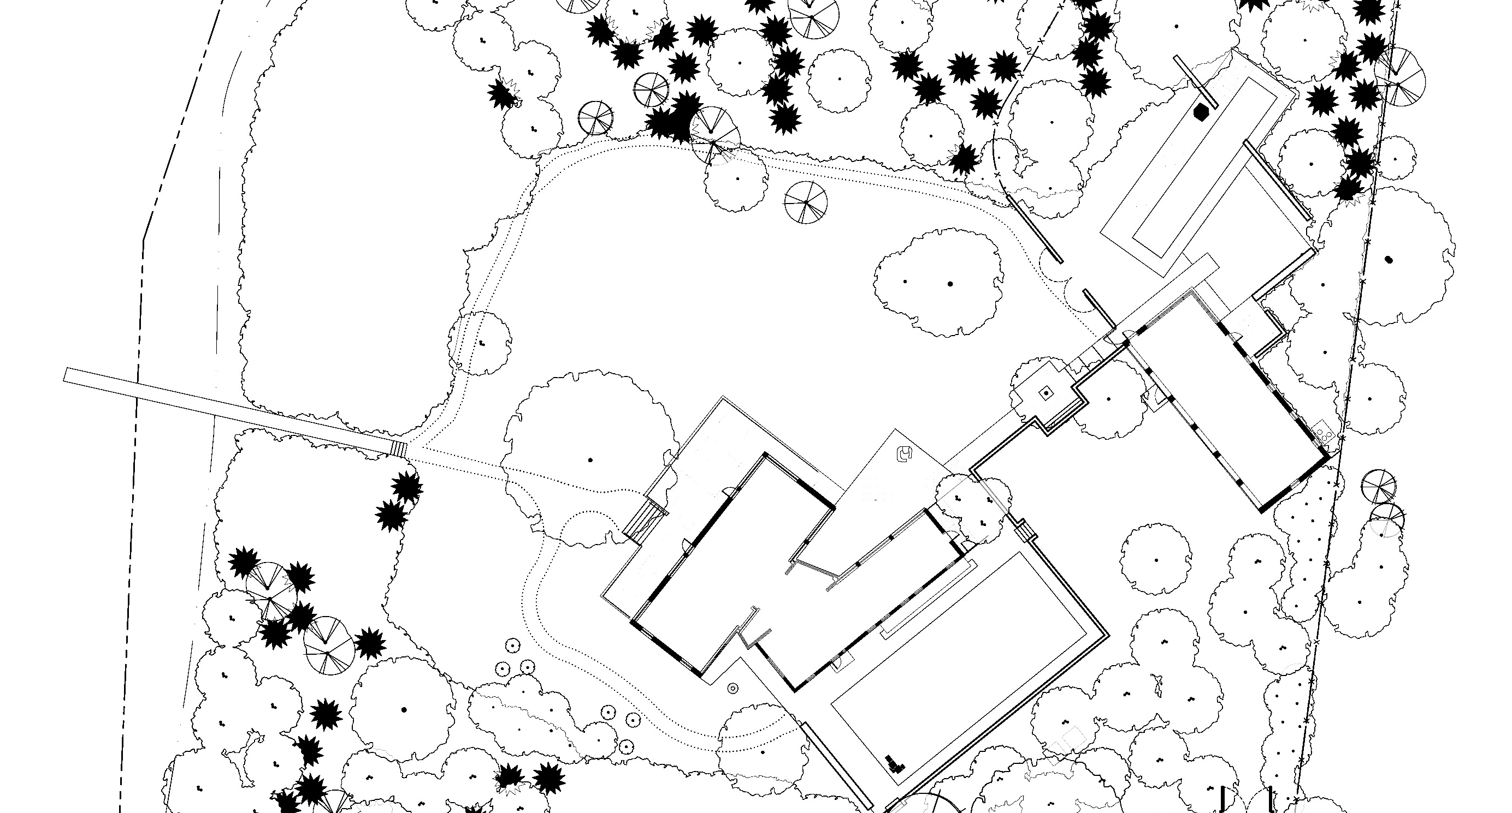

A copy of the site layout should be placed in each building so they are readily accessible by ALL occupants, visitors and emergency service personnel.

STEP 6

Training of staff/occupants

For the procedures of this plan to be followed in an orderly manner during an emergency, it is very
important that all members of the emergency team and occupants are thoroughly familiar with what is expected of them. For this to occur, it is necessary for the facility to have education on procedures, roles and responsibilities and to undertake exercises to test the emergency procedures.
The Emergency Planning Committee (EPC) that has been established is required to ensure the delivery of education and training for all occupants occurs and to conduct annual exercises on these procedures.
The exercises should test the arrangements and procedures that form the Bush Fire Emergency Management and Evacuation Plan, and include the following:
Decision to evacuate or shelter
What and where are the evacuation routes and refuges?
What are the Bush Fire Action Statements? Who has responsibility and for what?
What specific arrangements have been made for transportation and accommodation (if required)?
A drill for each scenario should be undertaken each year prior to the Bush Fire Season to make sure everyone is understands their roles in an emergency.

Additional awareness training

Where the decision is to shelter, it is beneficial for occupants to undergo bush fire awareness training to provide an understanding of a bush fire emergency. Where staff members would be required to monitor the building for fire activity (burning embers etc.), it is recommended that
they are provided with bush fire awareness/basic firefighting training. Contact your local NSW RFS Fire Control Centre who may be able to assist with this.
For additional information on the education and training of occupants, refer to AS3745 Planning for emergencies in facilities 2010.

Glossary

assembly point | The designated place or places where people assemble during the course of an evacuation.
District Emergency Management Officer (DEMO) | For emergency management purposes, NSW is divided into emergency management districts. Each Emergency Management District has a District Emergency Management Committee. The Committee is chaired by the District Emergency Operations Controller (DEOCON), supported by  the District Emergency Management Officer (DEMO). The DEMO is also responsible for assisting local committees and communities within the relevant District on emergency management matters.
emergency | An event that arises internally, or from external sources, which may adversely affect the occupants or visitors in a facility, and which requires an immediate response.
Emergency Planning Committee (EPC) | Persons responsible for the documentation and maintenance of an emergency plan.
Emergency warning and intercommunication system  (EWI | A combined emergency warning and intercommunication system that facilitates both way communications and control during an emergency.
evacuation | The orderly movement of people from a place of danger.
Local Emergency Management Officer (LEMO) | The State is divided into Local Government areas with a Local Emergency Management Committee for each area. This Committee is chaired by a senior representative of the council, and is supported by a Council appointed Local Emergency Management Officer (LEMO).
occupant | A person attending a facility on a permanent or temporary basis, such as an employee, contractor, student or resident, but not a visitor
on-site refuge | A building within the premises that is able to accommodate the people that will shelter. The place is not under threat from a bush fire.
off-site refuge | A venue at another location some distance away that is able to accommodate all the people being evacuated. The place is not under threat from a bush fire.
relocation | Movement of persons and/or organisations to an alternate area
State Environmental Planning  Policy (SEPP) | State Environmental Planning Policy (SEPP) is a legislated policy that deals with issues significant to the state and people of New South Wales.
sheltering | Procedures for a relevant situation where the safest course of action is to remain in a building or location.
support needs | People with physical, intellectual, visual, or auditory disabilities or impairments, either temporary or permanent who require support. It also includes aged persons and juveniles who are dependent on others for their care and wellbeing.

Name of facility:
BUSH FIRE EMERGENCY MANAGEMENT AND EVACUATION PLAN

Kapooka Public School
...................................................................................................................................................................................................

...................................................................................................................................................................................................

Address

Sturt Ave. Kapooka NSW 2661
...................................................................................................................................................................................................

...................................................................................................................................................................................................

Prepared by:
Principal - Lyn Eacott
........................................................................................................

Authorised by:

........................................................................................................

Date: .27 September 2017

TO BE REVIEWED ANNUALLY

Facility Details

This plan is for: .K...a..p..o..o..k..a...P..u..b...li.c...S...c.h..o..o...l...............................................................................................................
Name of facility

and has been designed to assist management to protect life and property in the event of a bush fire.

This Plan outlines procedures for both sheltering (remaining on-site) and

evacuation to enhance the protection of occupants from the threat of a bush fire. The Primary Action to follow under normal bush fire conditions is to:
✔
Shelter Evacuate

Contact person: .L..y..n...E...a..c..o..t.t..................................................................................................................................
Position / role: .P...r.i.n..c..i.p..a..l........................................................................................................................................
0408 669 192
02 6931 2703
Phone number (BH): .................................................. Phone number (AH): ............................................
Type of facility: .S...c..h..o..o..l................................. Number of buildings: .5..........................................................
80
9
Number of employees: .......................10.................... Number of occupants: .............................................
Number of occupants with support needs: .N...i.l.....................

Provide description of support needs:

Roles & Responsibilities

The following outlines who has the responsibility of implementing the emergency procedures in the event of a bush fire.

Position | Name or person | Building / area of Mobile phone number responsibility

Chief Warden | Lyn Eacott | All | 0408669192
Deputy Warden | Robyn Geale | All | 0411 299 147
Area Warden | Jose Van Dijk | All | 0407 454 004
Area Warden | Paula Hounsell | All | 0413 136 279

Emergency Contacts

Name of organisation | Office / contact | Phone Number

NSW Rural Fire Service | Local Fire Control Centre | 000 Emergency / 6971 4500
NSW Rural Fire Service | Bush Fire Information Line | 1800 679 737  1800 NSW RFS
NSW Rural Fire Service | Website | www.rfs.nsw.gov.au
NSW Police Force | Wagga Police | 000 Emergency / 6922 2599
Fire Rescue NSW | Turvey Park | 000
Kapooka Fire | Kapooka Fire Section | Emergency 6933 8424 General 6933 8488
SES | NSW State Emergency Service | 132 500
NSW Ambulance | Ambulance NSW | 000
Hospital | Wagga Base Hospital | 6938 6666

SHELTERING PROCEDURES
Evaluation of the safety of employees and occupants has determined that it would be safer for ALL persons to shelter in a designated refuge.

The following are the designated refuges allocated within the premises.

Designated refuges

a. .C....l.a..s..s...r.o...o..m....s....a..n...d...O....f.f.i.c...e....a..r..e..a....(.B...u...i.l.d..i.n...g....A...).........................................................................................................................................

b. ..........................................................................................................................................................................................................................

c. ..........................................................................................................................................................................................................................

d. ..........................................................................................................................................................................................................................

Procedure for sheltering during a bush fire emergency

Trigger
Action

a. .F...i.r..e...w....i.t.h...i.n...5....k..m.....o...f..s...c..h...o..o...l...D...a...y..s...o...f..e...x..t.r..e...m...e....&...<....... | a. .S...h...e..l.t..e..r...i.n....d..e...s..i.g...n..a...t.e..d....r..e..f..u..g...e..s........................................
b. .W.....h..e...n....d..i.r..e..c..t..e..d....b..y....E...m....e..r..g..e...n..c...y...S...e...r.v..i.c...e..s..................... | b. .I..m...p...l.e..m....e...n..t...B...F...E...M...P..............................................................
c. .W.....h..e...n....d..i.r..e..c..t..e..d....b..y....W....H....S....D...i.r..e..c..t..o..r../.D...i.r..e..c..t..o..r...P...S........... | c. .I..m...p...l.e..m....e...n..t...B...F...E...M...P..............................................................
d. .W.....h..e...n...P....r.i.n...c..i.p..a...l..j.u...d..g...e..s....s..h...e..l.t.e...r...n..e...c..e..s...s..a...r.y................. | d. .I..m...p...l.e...m...e...n..t...B...F...E...M...P..............................................................

After the bush fire emergency

a. Chief Warden to inspect outside of buildings for ember impact and abatement of radiant heat.
b Report to Emergency Services.
c. Incident Report and Support Hotline 1800 811 523 (option 1)
d. Report to DEC Director Public Schools and WHS Directorate.
e. Maintain fire safety.

EVACUATION PROCEDURES
Evaluation of the safety of employees and occupants has determined that it would be safer for ALL persons to evacuate to a designated refuge.

Designated assembly points
1. .. .N...o...n...b...u..s...h...f..i.r.e....e...m...e...r.g...e..n...c..y....-..B....a..s..k...e..t.b...a..l.l...C...o..u...r.t..................................................................................................................................
2. ...B...u..s...h...f..i.r.e....E...m....e..r..g..e...n..c...y...-...C...o...v..e..r..e..d....O....u..t..d..o...o..r...L..e...a..r..n...i.n..g....A...r.e...a...........................................................................................................
3. ...P...i.c..k....U...p....P...o..i.n...t..-...B...u...s...Z...o..n...e....i.n...f..r.o...n..t...o..f...t.h...e...s...c..h..o...o...l...........................................................................................................................

4. ..........................................................................................................................................................................................................................

Refuge (primary)
Name of venue (primary): Kapooka Neighbourhood Centre
Address of venue: ...S...t.u...r.t...A...v..e......K...a..p...o...o..k..a....N...S...W......2..6...6...1...........................................................................................................................
Nearest cross-street:...F...l.i.n..d...e..r..s...D...r..i.v..e.........................................................................................................................................................
Map reference:...2..7...6..1...0..1.........8...3..2...7..1...S....L...a..k..e....A...l.b...e..r..t..1...:.2...5..,.0...0..0.................................................................................................................

Phone number:................................................................................................................................................................................................

Transportation arrangements
Number of vehicles required: ...N...i.l..-...T...r.a...n..s...p..o...r.t...b..y....f.o...o..t.......................................................................................................................
Name of organisation providing transportation: ...............................................................................................................................

Contact phone number: ..............................................................................................................................................................................

Time required to have transportation available: ................................................................................................................................

Estimated travelling time to destination:..............................................................................................................................................

Refuge (alternate)
Name of venue (alternate): Red Hill Public School .
Address of venue: ...H...a...w...k..e...s...P...l.a...c..e....N...S...W......2..6...5..0......................................................................................................................................
Nearest cross-street:...B...o..u...r.k...e...S...t..r.e...e..t........................................................................................................................................................
Map reference:...3..1...6..1...0..8........8..3...2..7...1...S....L..a...k..e....A...l.b..e...r.t...1...:.2..5...,.0...0..0..................................................................................................................

Transportation arrangements

2 x 54 Seat Buses
Number of vehicles required:
....................................................................................................................................................................

Busabout
Name of organisation providing transportation: ...........
....................................................................................................................

6921 2316
Contact phone number:
..............................................................................................................................................................................

Time required to have transportation available: ................................................................................................................................

15 Minutes
Estimated travelling time to destination: ..........................
....................................................................................................................

Before and at the commencement of the Bush Fire Danger Period, we will:

Ensure that all staff are prepared in accordance with the Bush Fire Emergency Management Plan
a.
..........................................................................................................................................................................................................................

Ensure that all persons are informed of the Evacuation / Shelter-in-place procedures
b.
..........................................................................................................................................................................................................................

Update contact details for staff and parents, check emergency folder is up to date
c.
..........................................................................................................................................................................................................................

Ensure buildings and surrounds are prepared and maintained
d.
..........................................................................................................................................................................................................................

Procedures for evacuation in the event of a bush fire

Trigger
Action

a. .C....a..t.a...s..t.r..o..p...h..i.c....F...i.r.e....D...a...n..g...e..r................................................ | a. .C ....o..n...s..i.d..e...r...c..l.o..s...i.n..g....s..c...h..o...o..l..................................................
b. .W.....h..e...n...d...i.r.e...c..t.e...d....b..y....E...m....e..r..g..e...n..c..y....S...e...r.v..i.c...e..s..................... | b. .I.m....p...l.e..m....e...n..t...B...F..E...M....P..............................................................
c. .W.....h..e...n...d...i.r.e...c..t.e...d....b..y....W....H...S.....D...i.r.e...c..t.o...r.a...t.e.../.D...i.r..e..c...t.o..r...P...S..... | c. .I.m....p...l.e..m....e...n..t...B...F..E...M....P..............................................................
d. .W....h...e...n...P...r..i.n..c...i.p..a...l..j.u..d...g...e..s....e..v..a...c..u...a..t.i.o...n....n..e...c..e...s..s..a...r.y......... | d. .I..m...p...l.e..m....e...n..t...B...F..E...M....P..............................................................

After the bush fire event

No person should re-enter any evacuated building until advised by Emergency Services
a.
..........................................................................................................................................................................................................................

When not impacted by fire Principal/ Asset Management should first assess whether the buildings are safe
b.
..........................................................................................................................................................................................................................

If buildings were impacted, assessment should be made by Asset Management Officer prior to return
c.
..........................................................................................................................................................................................................................

Inform Police/Emergency Services of the return of people to the premises
d.
..........................................................................................................................................................................................................................

Attachments

Occupant/employee listing
Contact details for parents/guardians Site Layout of Premises

APPENDIX 1

Example Bush Fire Action Statements and triggers

The following are examples of some actions statements and when they should occur (triggers). You may identify additional statements and triggers relevant to your situation.

Before and at the commencement of the Bush Fire Danger Period:

Ensure that the staff are prepared in accordance with the Bush Fire Emergency Management and Evacuation Plan.
Ensure that all persons are informed of the evacuation/shelter-in-place procedures.
Ensure that families are provided with a copy of the procedure “What to do if the centre is to be evacuated” upon arrival at the centre (for schools and child care centres etc).
Ensure building and areas around buildings are prepared and maintained.
Ensure any firefighting equipment (hoses etc.) is serviceable and available.
Update contact details of staff and occupants.
Contact and update emergency services with the premises’ contact details.
Contact refuges for potential use during a bush fire emergency.
Contact transport suppliers for potential use during a bush fire emergency.

In the event of a bush fire in the surrounding area, occupants of the premises shall follow the procedure outlined below:

When aware of the bush fire in the local area:
Consult the NSW RFS website, 1800 NSW RFS, smart phone applications and local firefighting resources for fire situation and updates.
Inform staff and occupants of the fire situation.
Ensure that the person in charge, ie. Chief Warden, has a mobile phone and is contactable.
Advise the local emergency services that the centre is operating, and that it will need to be advised early in the event of an evacuation being necessary.
Make arrangement for transportation (for evacuation).

In the event of an approaching bush fire threatening the premises within X hours, the primary action to evacuate/shelter will take place, staff and occupants of the premises shall follow the procedure outlined below:

Designated Fire Warden will take control of the situation.
Remain calm and explain to the occupants what is happening.
Staff to ensure all doors and windows closed within the premises.
Sheltering
Move all persons to the designated refuge.
Ensure all persons are accounted for (use listing of occupants and visitors register).
The Fire Warden (or person responsible) is to advise the local emergency service (include phone number) that the centre is sheltering- in-place (include how many people and which building on site).
After all the occupants have been relocated to refuge, nominated staff will commence contacting relevant families affected.
Maintain situational awareness through radio, NSW RFS website, 1800 NSW RFS, smart phone applications and local firefighting resources.
Two persons to make regular exterior visual inspection (wearing appropriate protection from bush fire) of the refuge for embers and extinguish where possible or call 000
for assistance.

Evacuation

The Fire Warden (or person responsible) is to advise the local emergency service (include phone number) that the centre is being evacuated (include how many people and where they are going).

Arrange for vehicles to meet at designated assembly point for pick up of persons.
Contact refuge and inform them of pending arrival.
Move all persons to the assembly point for evacuation.
Ensure all persons are accounted for prior to departure (use listing of occupants).
Ensure all site buildings have all doors and windows closed prior to leaving site.
At refuge, move all persons inside and ensure all persons are accounted for and safe.
The Fire Warden (or person responsible) to advise the local emergency service (include phone number) that the all persons have been evacuated and are accounted for and safe at the designated refuge.
After all the occupants are accounted for and safe at the designated refuge nominated staff will commence contacting families affected.
Maintain situational awareness through radio, NSW RFS website, 1800 NSW RFS, smart phone applications and local firefighting resources.

Forced evacuation – as a result of bush fire in the surrounding area and due to its
severity, fire authorities require occupants to be evacuated to a refuge.

Fire Warden (or person responsible) to liaise with the police/emergency service giving evacuation orders and provide them with the number of persons and any support needs that are to be considered for transportation (if no on-site transportation is available).
Arrange for vehicles to meet at designated assembly point for pick up of persons.
The Fire Warden (or person responsible) is to advise the local emergency service (include phone number) that the centre is evacuating due to police direction (include how many people and where they are going).
Move all persons to the assembly point for evacuation
Ensure all persons are accounted for prior to departure (use listing of occupants).
At refuge, move all persons inside and ensure all persons are accounted for and safe.
The Fire Warden (or person responsible) is to advise the local emergency service (include phone number) that the all persons have been evacuated and are accounted for and safe at the refuge.
After all the occupants are accounted for and safe at the refuge, nominated staff will
commence contacting relevant families affected.
Maintain situational awareness through radio, NSW RFS website, 1800 NSW RFS, smart phone applications and local firefighting resources.

When the bush fire threat has passed and the area is deemed safe by emergency services:

No person should re-enter any evacuated building until advised by the emergency service.
The Fire Warden (or person responsible) to arrange the movement of occupants back to the site and or their separate accommodation.
All occupants are to be accounted for on their return.
Inform the police/emergency service of the return of persons to the premises.

Kapooka Public School
Sturt Avenue
GA Shed
Roller door
Sports Shed roller door
Kapooka NSW 2661

SCHOOL MAP
Bushfire evacuation

busstop
1/2/3 Class Room
Toilet
Uniform Supplies
Toilet
Canteen
Bag Room
Store Room
Principal’s Office
Toilet
Path
Room
Store Room
DSTA /
Counsellor Office
K/1 Classroom
Staff Room
Store Room
Bag Room
3/4/5/6 Classroom
Administration
Office

